# OneGrade Installation Guide

Total College Ltd. shall, under no circumstances, be liable for any damages or losses arising out of the use or inability to use this software product or any other software product used in conjunction with this software product.

The OneGrade Installation is available by download from [www.totalcollege.co.uk](http://www.totalcollege.co.uk)

Download the file named OneGradeInstallationFiles_1_0_0_0.zip (approx. 6MB)

Using Windows File Explorer, right click the file and select to unzip this file to a new folder. After unzipping the file you will see two folders:

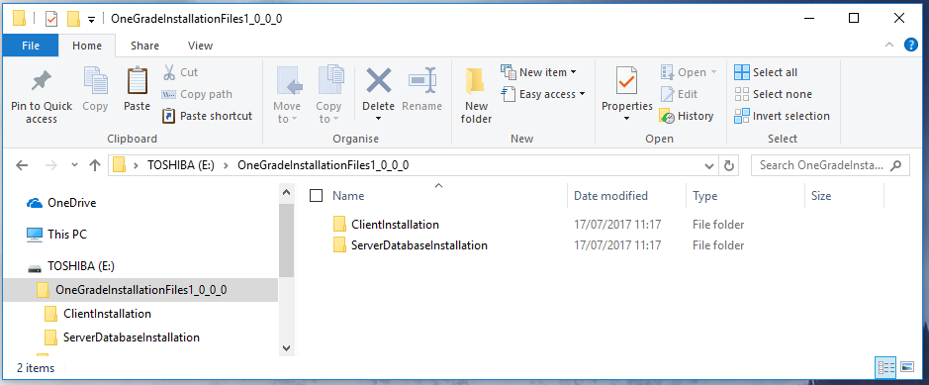

The folder “ClientInstallation” contains the installation file required to install the OneGrade Client software on each Client PC.

The folder “ServerDatabaseInstallation” contains the files requires to install the OneGrade database on a suitable SQL Server.

## Server Installation

Using Windows Explorer, Click the folder “ServerDatabaseInstallation”. You will see a set of files:

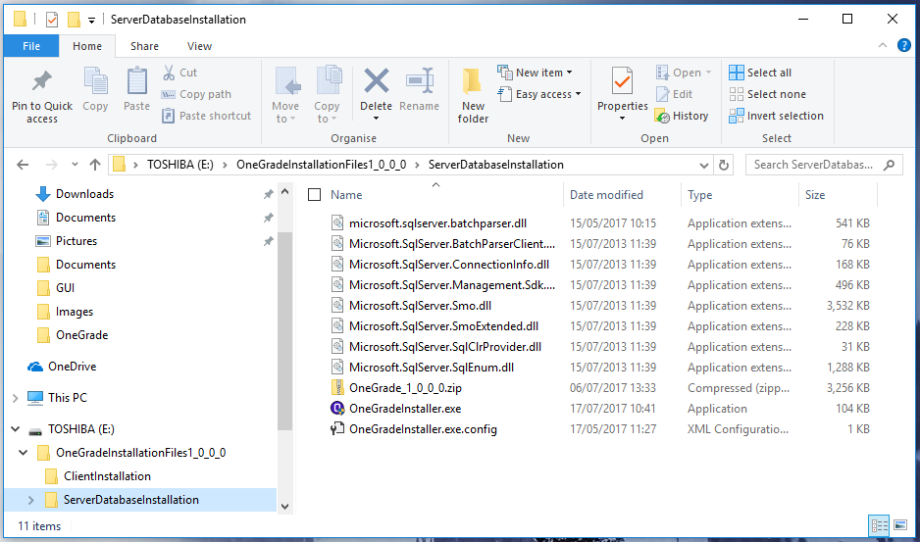

Click on the file OneGradeInstaller.exe (Note that you may not see the .exe extension depending on your File Explorer settings) and the OneGrade Installer will open.

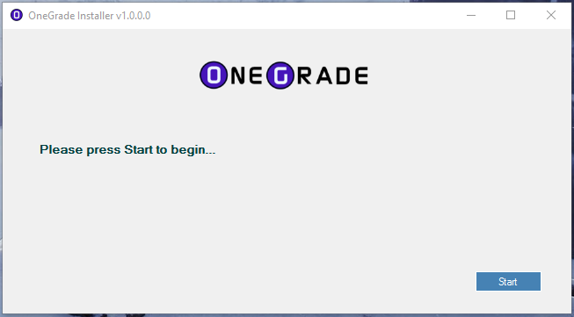

When you press the start button, it will unpack the files it needs to carry out the installation. This will only take a few seconds. Ensure that you have at least 50MB of space available for this.

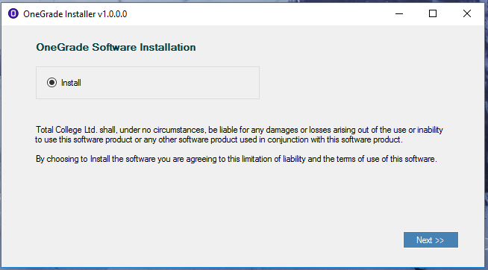

Choose to Install the Software. Please note that by selecting to install the software, you understand and agree to the terms of use as described. Press **Next>>** to continue.

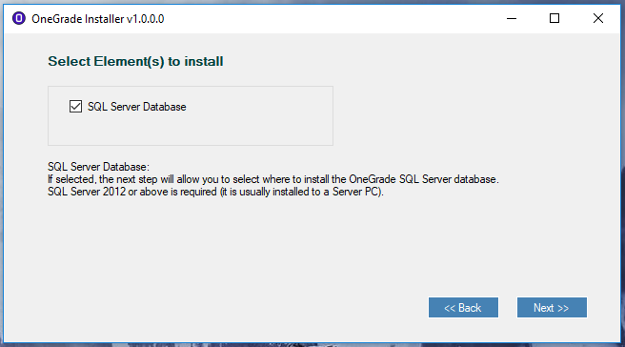

On this screen, select to install the SQL Server Database. The SQL Server Database may only be installed on a server on which SQL Server has been installed.

The SQL Server Database must be installed on a Server PC running SQL Server 2012 or above with the latest applicable SQL Server Service Pack applied.

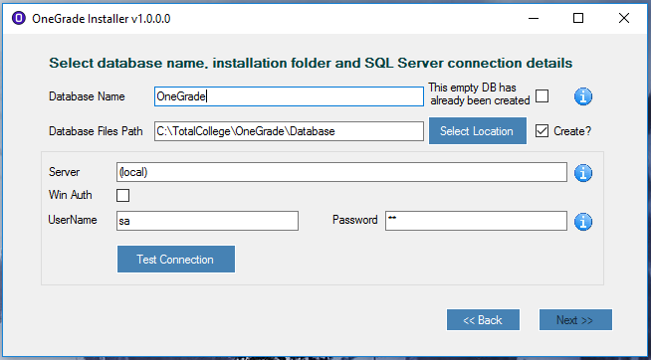

By default, the *Database Name* is OneGrade. You may choose to install the database under a different name. In this case, simply enter a new name.

You may choose to alter the location of the *Database Files Path* if necessary. This is needed when you are creating a new database.

You have the option to state whether the database already exists (by ticking the *This empty DB has already been created* checkbox). Ticking this means that an empty database (i.e. containing no objects such as tables, views, stored procedures, functions etc.) has already been created on the server and there is no need to create the database.

If the *This empty DB has already been created* checkbox is ticked, the *Database Files Path* is disabled as it is not needed by the installer:

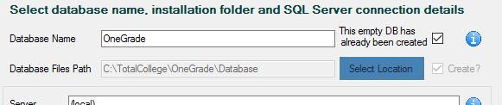

If you wish the Database to be created by the installer, you must untick the *This empty DB has already been created* and enter a File Path in the *Database Files Path* box. This is a file path local to the PC on which you are running the installer. If you are running the installer remotely to the Server on which the SQL Server is located, you may wish to untick the *Create?* checkbox as creating the *Database Files Path* on the local PC will be of no use. You must ensure however that the *Database Files Path* is available to the SQL Server itself or you will receive a “FilePath not found” error when it attempts to create the database.

In the *Server* box, enter the name of the SQLServer. If you wish to install the database to a SQL Server instance then use the format [ServerName]\[ServerInstance]. If you are not connecting via the default port 1433, you must specify the port number assigned to the SQL Server. Use the format [ServerName]\[ServerInstance], xxxx or [ServerName],xxxx. Instead of a named *Server*, you may use the IP Address instead.

You may choose to connect via Windows Authentication (*Win Auth*) using the username you are currently logged onto the PC as, or use a SQL server *UserName* and *Password*. You must use an account with sufficient permission to create a database and set permissions. The “sa” account is recommended.

Once the details have been provided, you must press the **Test Connection** button. If a connection is valid, it will confirm this and the **Next>>** button will be enabled.



The next screen confirms a summary of your installation options. To Install the database, press the **Finish** button. Installation will typically take a couple of minutes.

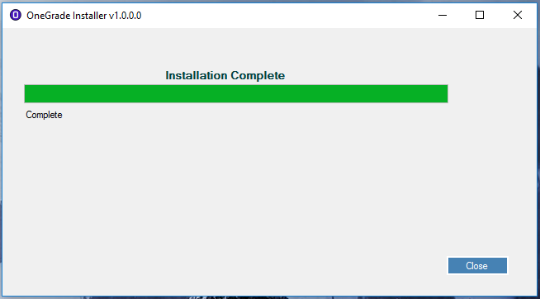

Pressing **Close** will close the installer and remove the unpacked file folder and its contents.

## Client Installation

Using Windows Explorer, Click the folder “ClientInstallation”. You will see the file:

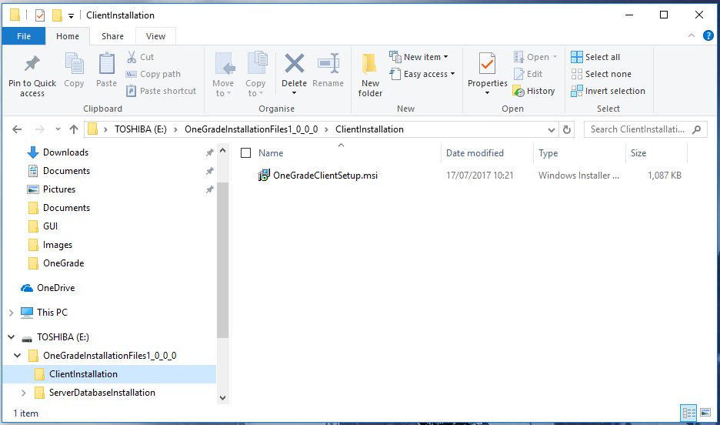

The File “OneGradeClientSetup.msi” is used to install the Client Application onto each client PC that will use OneGrade.

The Client Application must be installed on a PC running Windows 7 or above. It requires .NET 4.5.2 which will be available on all PCs running Windows 7 or above as long as windows updates have been applied since 2014.

Click on the file OneGradeClientSetup.msi (Note that you may not see the .msi extension depending on your File Explorer settings) and the OneGrade Client Setup installer will open. Follow the setup wizard by pressing the **Next >** button.

|  |  |
| --- | --- |
|  |  |

The default location for the installed files is “C:\Program Files (x86)\TotalCollege\OneGrade”. You may change this if necessary.

After confirming the Installation Folder, you will be asked if you want to make changes to the PC. Answer *Yes* to this question to proceed with the installation.

The following Client files will be installed to this *Client Files Path* location:  
**OneGrade.exe, OneGrade.exe.config, OneGrade256trans.ico**

In addition, the file **DatabaseConnection.xml** will be installed to:C:\ProgramData\TotalCollege\OneGrade

A Common Start Menu file **OneGrade.lnk** will be installed to:  
C:\ProgramData\Microsoft\Windows\Start Menu\Programs\TotalCollege\OneGrade

And a desktop shortcut file (**OneGrade.lnk**) will be installed to:  
C:\Users\[UserName]\Desktop

Note that the C:\ProgramData folder is, by default a *hidden* folder. Use your Windows File Explorer settings to “show hidden files and folders” if you need to navigate to a file in this location.

## Starting the OneGrade Client Application for the first time

When you have installed the OneGrade Client successfully, there should be a shortcut on the desktop. Alternatively, you can use the Windows Start Menu to locate the OneGrade Application.

When you start OneGrade, if it cannot locate the database, it will open the application on the Database Connection Settings screen:

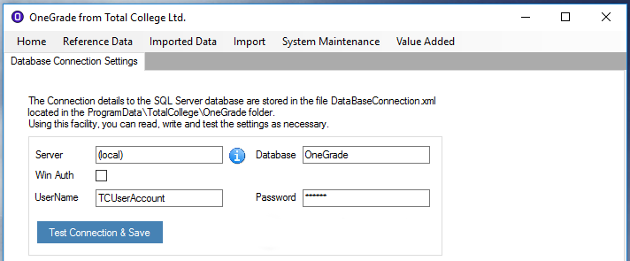

Using this screen, enter the correct details for the Server and Database. The TCUserAccount is an account created by the installer with the appropriate permissions set on all of the database objects.

When the connection has been successful, you will be asked to restart.

If there is no licence key or if it is invalid or expired, you will be informed and asked to enter a new licence key. OneGrade will open showing the Licence Key Maintenance Screen so you can do this. Licence keys are supplied directly by Total College Ltd.

When OneGrade is first used, you will be prompted to log in. The installer will create an *Administrator* account. There is no password.

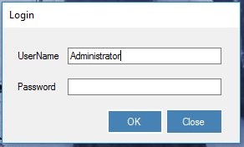

It is recommended that you set a password using the User Accounts screen at the first available opportunity. You may also set up other accounts using this screen, and if you choose to, enable Windows Authentication by adjusting the setting using the “System Settings – Flags” screen.