**OneGrade Data Dictionary**

There are two modules within OneGrade that are used to measure progress:

* OneGrade Value Added
* OneGrade English / Maths

The OneGrade Value Added module is able to create targets for qualifications based upon National DfE Level 3 Value Added data and Completion-Attainment data. As students progress through their courses, In Year progress and final completion grades can be recorded and value-added calculated.

Data Imported into the OneGrade Value Added module is summarised into the **EstActVA** table.

The OneGrade English / Maths module is able to calculate start points and progress for English and Maths Level 2 and below qualifications. The Progress measure for English and Maths is sufficiently different to the Value Added and Completion-Attainment calculations as to warrant its own module and hence Summary tables.

Data Imported into the OneGrade English / Maths module is summarised into the **EngMat_Enrolment_InYear** and **EngMat_English_InYear** / **EngMat_Maths_InYear** tables (Note the Student-based EngMat_English_InYear and EngMat_Maths_InYear have identical fields).

The following pages describe the categories of fields in each summarised table and location of the fields on the Summary screens within OneGrade. The accompanying MS Excel document lists each available field with notes where applicable.

**EstActVA Table Guide**

The EstActVA table holds summarised Value Added data for the OneGrade System.

The accompanying spreadsheet is intended to enable MIS staff, Analysts and Report writers to quickly determine the location and purpose of all the fields in the EstActVA table. The records are sorted into the categories below. The fields are either imported from college and DfE records or derived from that data.

Note that many numeric fields are repeated in the EstActVA, but with a 2dp suffix. These show the same value but to 2 decimal places.

1. Student Details

Details about each student include age, gender, ethnicity etc. There are a further eleven ‘User-Defined’ fields to enable the collection of college specific data.

1. Course & Qualification Details

Learning and Qualification Aims details are from Ofqual and DfE sources whereas course data is imported from college data. There are four ‘User-defined’ fields for college specific use.

1. Enrolment Details

Details about each enrolment include dates, completion status, grade etc. There are a further eleven ‘User-Defined’ fields to enable the collection of college specific data.

1. Quals on Entry

Qualifications on Entry score attained by the student prior to the current academic year.

1. Value Added

The Target Grade based upon national data published by the DfE and the calculated Value Added Score is included.

1. In-Year VA

Details about the In-Year Grades, Points and Value Added scores in the current academic year. Also, the most recently completed In-Year fields are included in this section

1. Grades, Points, VA calculated using AcYr data

At the start of an academic year, the national data from the DfE is not yet published for the previous academic year. When the national data is available (usually halfway through the academic year), the latest national data can be used. These fields use this latest available data to calculate the target grade and Value Added Score.

1. Imported Actual DfE data

The DfE make enrolment-level data available to colleges and this can be imported into OneGrade. These fields display this data.

1. Redundant

These fields are now redundant.

**Value Added – Estimated v Actual Analysis screen**

This displays data directly from the EstActVA table. The numbered (in red) checkboxes at the top left of the screen relate to the Checkbox Number column in the spreadsheet. Fields are displayed when these checkboxes (or a combination of checkboxes) are ticked. These are displayed in red beneath each column. After checking the boxes, pressing “Show” will display the related columns in the main grid of data.



**Value Added – Estimated v Actual Analysis screen (In-Year Checkboxes)**

This screen shot shows the additional columns available when the In Year Value Added assessment “Point” and “Latest” boxes at the top right of the screen are ticked. For brevity, only the first 3 of the 12 Assessment Point columns have been ticked.

The red numbers next to the tick boxes at the top right correspond to the red numbers underneath the columns – as each box is ticked these additional columns will appear upon pressing the “Show” button next to the tick boxes.

**Value Added – Estimated v Actual Analysis screen (Other Columns)**

A large number of other columns may be displayed in the grid by selecting them from the list of available columns (a drop-down list labelled “Add a Column” in the lower left of the screen) and pressing the Add button alongside.

User Defined fields are shown in the list as the name they have been assigned in the User Defined Fields maintenance screen (from the main menu, select System Settings | User Defined Fields).

These fields are:

|  |  |  |  |
| --- | --- | --- | --- |
| QualificationDescription | StartDate | LLDDandHealthProblemCode | CA_QualTypeDescription |
| WholeQualID | PlannedEndDate | LLDDandHealthProblemDefinition | TeachingGroupCode |
| CA_LearningAimTitle | ActualEndDate | FreeSchoolMeal | TeachingGroupTitle |
| CA_LearningAimRef | CompletionID | CompletionDescription | NVQLevel |
| AB | CourseTitle | AgeOn31Aug | PersonalTargetGrade |
| DC | DOB | WDNumDaysAfterStart | OutcomeID |
| ABAcronym | EthnicityCode | IsGraded | OutcomeDescription |
| DCName | EthnicityDefinition | InScope | TargetFrozenAcademicYearID |
| DCType | Gender | CollegeMapped | CA_QualTypeDescription |
| GradeRange | TutorGroupCode | MappingInfo | TeachingGroupCode |

**English / Maths By Student**

English Data is held in the table EngMat_English_InYear

Maths Data is held in the table EngMat_English_InYear

Additional Fields are displayed depending on the checkboxes that are ticked.

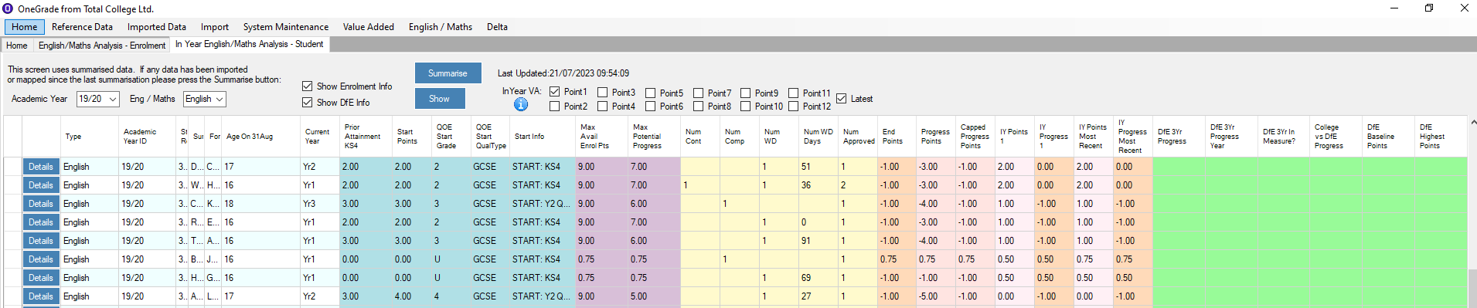

A number of other columns may be displayed in the grid by selecting them from the list of available columns (a drop-down list labelled “Add a Column” in the lower left of the screen) and pressing the Add button alongside.

|  |  |  |  |
| --- | --- | --- | --- |
| DOB | EthnicityCode | EthnicityDefinition | Gender |
| TutorGroupCode | LLDDandHealthProblemCode | LLDDandHealthProblemDefinition | FreeSchoolMeal |
| Exempt_DiffDisab | Exempt_Overseas | Exempt_LessThan150Hrs |  |

Not displayed above are the Student User Defined fields. These are shown in the drop-down list as the name they have been assigned in the User Defined Fields maintenance screen (from the main menu, select System Settings | User Defined Fields).

**English / Maths By Enrolment**

English and Maths Data is held in the table EngMat_Enrolment_InYear

Additional Fields are displayed depending on the checkboxes that are ticked.

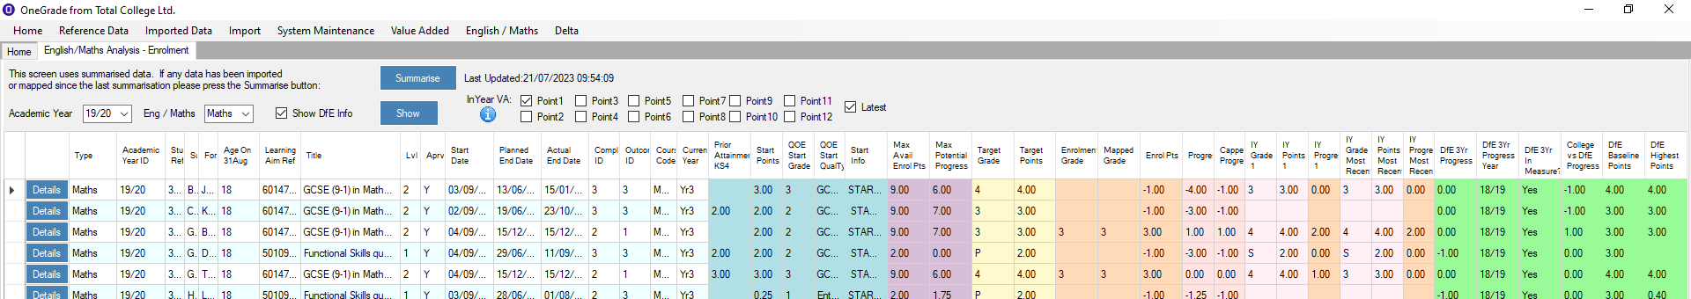

A number of other columns may be displayed in the grid by selecting them from the list of available columns (a drop-down list labelled “Add a Column” in the lower left of the screen) and pressing the Add button alongside.

|  |  |  |  |
| --- | --- | --- | --- |
| DOB | EthnicityCode | EthnicityDefinition | Gender |
| TutorGroupCode | LLDDandHealthProblemCode | LLDDandHealthProblemDefinition | FreeSchoolMeal |
| Exempt_DiffDisab | Exempt_Overseas | Exempt_LessThan150Hrs | CompletionStatus |
| WDNumDaysAfterStart | OutcomeDescription | CourseTitle | TeachingGroupCode |
| TeachingGroupTitle | PersonalTargetGrade |  |  |

Not displayed above are the Student, Enrolment and Course User Defined fields. These are shown in the drop-down list as the name they have been assigned in the User Defined Fields maintenance screen (from the main menu, select System Settings | User Defined Fields).